Brachycephalic Health Information
(Bulldogs and other short faced breeds)

Before adopting a bulldog or any other brachycephalic breed, there are several medical conditions that you should be aware of. Although bulldogs have great dispositions, they have a multitude of chronic medical conditions that can require extensive veterinary treatment. Make sure to consider the Petfinder or other pet insurance if adopting one of these dogs.

What does brachycephalic mean?
"Brachy" means "shortened" and "cephalic" means "head". The skull bones of brachycephalic dogs are shortened in length, giving the face and nose a "pushed in" appearance. Due to the shorter bones of the face and nose, the anatomy and relationship with the other soft tissue structures are altered; some of these changes can cause physical problems for the affected dog.
Examples of breeds that are brachycephalic include Bulldogs, Boxers, Boston Terriers, Pekingese, Chinese Pugs, Lhasa Apsos, Shih Tzus and Bull Mastiffs.

What is brachycephalic airway syndrome?
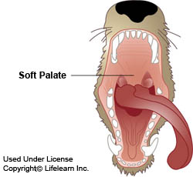
Brachycephalic airway syndrome refers to a particular set of upper airway abnormalities that affects brachycephalic dogs. This syndrome is also called brachycephalic respiratory syndrome, brachycephalic syndrome or congenital obstructive upper airway disease. The upper airway abnormalities that occur in this syndrome include stenotic nares, an elongated soft palate, a hypoplastic trachea and everted laryngeal saccules. An individual dog with brachycephalic syndrome may be affected with a combination of one or more of these abnormalities.
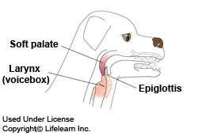
Dogs with stenotic nares have abnormally narrowed or small nostrils; the narrowing restricts the amount of air that can flow into the nostrils. A dog with an elongated soft palate (the soft part of the roof of the mouth) has a soft palate that is too long for the length of the mouth; the excess length partially blocks the entrance to the trachea at the back of the throat. A hypoplastic trachea means that the trachea or windpipe has a smaller diameter than normal. The laryngeal saccules are small sacs or pouches that are located just inside the larynx (voice box); these saccules evert (turn outwards) or are sucked into the airway by pressure associated with the increased respiratory effort caused by the stenotic nares and/or the elongated soft palate. Everted laryngeal saccules will further obstruct airway flow.
All dogs cool themselves through panting; they do not sweat like people so Bulldogs thermoregulatory apparatus is compromised because their surface area for heat exchange is very small. These anatomical abnormalities are what predispose bulldogs to heat stroke a life threating condition. A bulldog living in California CANNOT be an outdoor dog!!!! Additionally, you cannot walk a Bulldog when it is hot outside (about 6 months out of the year in Northern California).
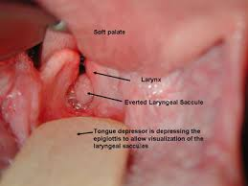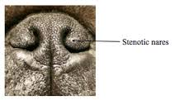
If your dog develops heat stroke get him to a veterinarian immediately…. Attempt to cool your dog down with water prior to transport, studies show owners that do this increase their pet’s survival percentage. Some Bulldogs have such difficult time breathing and are predisposed to aspiration pneumonia that they need special surgical procedures on their nares to widen them and in their throats to create more room. These procedures need to be done by a trained veterinarian. They are called a palate clip and everted laryngeal saccules removal. The stenotic nares can also be widened.
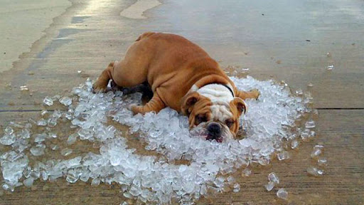
Hip Dysplasia and Cruciate Ligament Rupture:
Almost all Bulldogs have hip dysplasia and because of their hip problems, it predisposes them to cranial cruciate ligament rupture. This condition can require surgery to repair the ligament. They also have luxating patellas which is where the knee cap pops out of the groove and this also can lead to cranial cruciate ligament rupture.
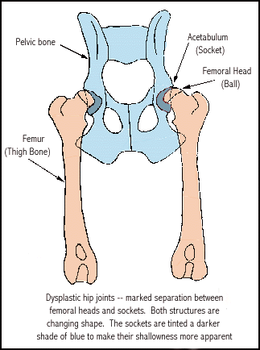
Dermatologic Conditions:
Bulldogs are prone to a variety of skin conditions including atopic dermatitis, food allergy, demodectic mange, seborrhea, and pyodermas involving either yeast or bacteria. The ears are considered an extension of the skin and bulldogs also get ear infections also called otitis. Bulldogs also get screw tail and face fold infections as well. It is important to clean out their wrinkles to help avoid these conditions.
Eye Conditions:
Entropion: eyelids roll in
Ectropion: eyelids roll out
Cherry Eye: gland of the third eyelid protrudes out
Distichiasis: very small eyelashes grow the wrong direction and rub on the eye.
Dry Eye: KCS or dry eye is when the eye no longer produces tears.
Corneal Ulcer: a scratch on the cornea (clear surface of the eye)
Conjunctivitis: an injection in the tissues around the eye
Cardiac Conditions:
Pulmonic Stenosis or a narrowing of the pulmonic heart valve and Aortic Stenosis or a narrowing of the aortic valve are two of the cardiac conditions that can affect Bulldogs. Ventricular septal defect or a hole in the tissue between the left and right ventricles of the heart. All of the above conditions can lead to congestive heart failure.
Miscellaneous Conditions:
Hypothyroidism where there is a lack of thyroid hormone and they dog is lazy, can gain weight and have skin problems. The treatment is to give thyroid supplementation.
Obesity: Bulldogs are prone to obesity and it can exacerbate other medical conditions.
Anesthesia risk: Bulldogs and other brachycephalic breeds are at risk for anesthetic procedures.

