Feral Cats
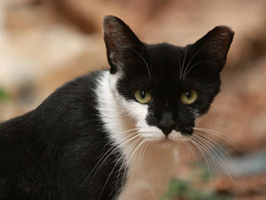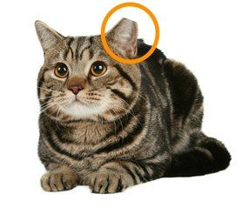
Feral cats are not socialized to people. They are generally wild and cannot be handled by humans.
Therefore, they are not adoptable. Feral cats don’t belong indoors and are typically wary of us. However, as members of the domestic cat species (just like pet cats), they are protected under state anti-cruelty laws.
Feral cats should not be taken to pounds and shelters.
Feral cats’ needs are not met by the current animal control and shelter system, where animals who are not adoptable are killed. Feral cats live full, healthy lives outdoors—but are killed in shelters. Even no-kill shelters can’t place feral cats in homes
If you bring a feral cat to No Father’s Day event at the SPCA and you identify it as a feral, its ear will be tipped to show that it has been neutered. If you are confused about this issue, please ask one of the SPCA spay neuter clinic staff members for help.

